DATABASE SYSTEM EXAM
A.Y 2021/2022

Contents

Conceptual Design 2
1. Choose the right level of abstraction: 2
2. Identify synonyms and homonyms 2
3. Standardize the sentences 2
4. Glossary 3
5. Reorganizing for Keywords phrases 3
6. DESIGN 5
6.1 FRUIT TABLE 5
6.2 ALLERGY TABLE 6
6.3 USER TABLE 6
6.4 OFFER TABLE 6
6.5 RECIPE TABLE 6
6.6 SENSOR TABLE 6
6.7 FRESHNESS TABLE 7
6.8 FINAL SCHEMA 7
7. Add constraints 8
8. Logical Design 9
8.1 Analysis of redundancy 9
8.2 Removal of composite and multivalued attribute 9
8.3. Removal of hierarchies 9
8.4. Partitioning/Merging of concepts 9
8.5. Choice of primary keys 9
8.6 New Business Rules 9
9.0 Physical Design 11
9.1 Procedures 11
Triggers 13
Views 14
JOB SCHEDULERS 15

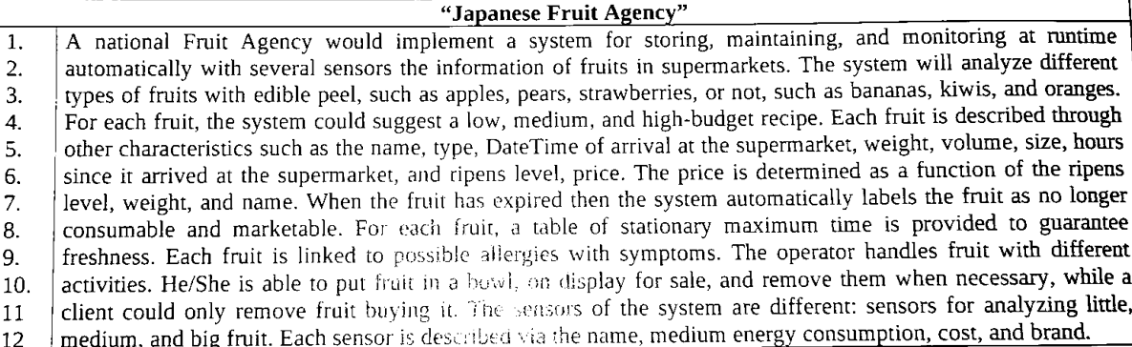

Conceptual Design

Choose the right level of abstraction:

- The type of the fruit could be SMALL, MEDIUM, LARGE base on its dimension
- DateTime of arrival is compose of the following format dd-MM-yyyy hh:mm:ss
  - dd: 2 values for represent days
  - MM: 2 values for represent months
  - yyyy: 4 values for represent years
  - hh: 2 values for represent hours
  - mm: 2 values for represent minutes
  - ss: 2 values for represent seconds
- The ripens level is within the range 0 - 1 where:
  - 0 – rotten fruit
  - 1 – fresh fruit

2. Identify synonyms and homonyms

No synonyms found

3. Standardize the sentences

For FRUIT we hold name, edible peel info, date of arrival, weight, volume, dimension, ripens level, price, freshness info.
For ALLERGY we hold name, symptoms.
For RECIPE we hold name and description.
For SENSOR we hold name, medium consumption info, cost, brand, scan dimension.
For OFFER we hold discounted price and discounted weight.
For USER we hold name, surname, type (customer/operator).
For FRESHNESS stationary table we hold the name of the fruit and the freshness days.

4. Glossary

Term | Description | Synonym | Links
FRUIT | The fruit under analysis | - | ALLERGY, RECIPE, SENSOR, OFFER, FRESHNESS
ALLERGY | A damaging immune response by the body to a fruit | - | FRUIT
RECIPE | A set of instructions for making fruit dishes | - | FRUIT
SENSOR | A device which detects or measures a physical property and records, indicates, or otherwise responds to it. | - | SENSOR
OFFER | A deduction from the usual cost | - | FRUIT, USER
USER | A client/customer that interact with this system | Customer / Client | OFFER
FRESHNESS | The quality of being new | - | FRUIT

5. Reorganizing for Keywords phrases

Phrases of general nature
- A national Fruit Agency would implement a system for storing, maintaining, and monitoring at runtime automatically with several sensors the information of fruits in supermarkets.

Phrases relating to FRUIT
- The system will analyze different
types of fruits with edible peel, such as apples, pears, strawberries, or not, such as bananas, kiwis, and oranges.
- Each fruit is described through other characteristics such as the name, type, DateTime of arrival at the supermarket, weight, volume, size, hours since it arrived at the supermarket, and ripens level, price.
- The price is determined as a function of the ripens level, weight, and name.
- When the fruit has expired then the system automatically labels the fruit as no longer
- consumable and marketable.

Phrases relating to ALLERGY
Each fruit is linked to possible allergies with symptoms.

Phrases relating to RECIPE
For each fruit, the system could suggest a low, medium, and high-budget recipe.

Phrases relating to SENSOR
The sensors of the system are different: sensors for analyzing little, medium and big fruit.
Each sensor is desribed via the name, medium energy consumption, cost, and brand.

Phrases relating to OFFER
He/She is able to put fruit in a bowl, on display for sale …

Phrases relating to FRESHNESS
For each fruit, a table of stationary maximum time is provided to guarantee Freshness.

Phrases relating to USER
The operator handles fruit with different activities. He/She is able to put fruit in a bowl, on display for sale, and remove them when necessary, while a client could only remove fruit buying it.

6. DESIGN

A hybrid type strategy was used for schema design. Using this approach, the various components was developed individually and then merged together in order to obtain the final schema.
Let’s start with the one that will characterize the basis of the schema that provides a view on the different entities and relationships without going into detail

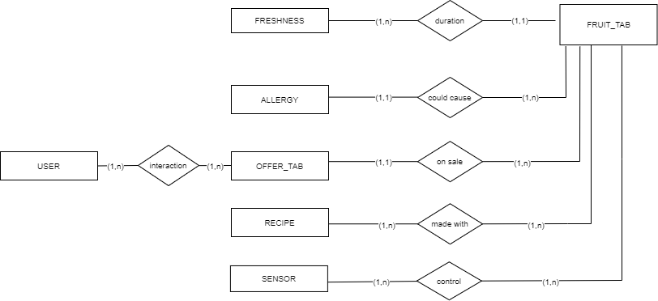
Now we can go into the detail on each entity

6.1 FRUIT TABLE

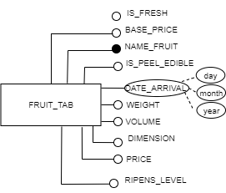
Ripens level is a value in 0-1
IS_PEEL_EDIBLE, IS_FRESH are Boolean value True, False

6.2 ALLERGY TABLE

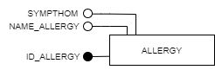

6.3 USER TABLE

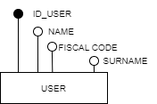

6.4 OFFER TABLE

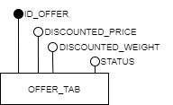

The status is one of:
- SOLD customer buy offer fruit
- ON SALE available fruit offer
- REMOVED the fruit ripens level are 0 or the customer delete the offer.

6.5 RECIPE TABLE

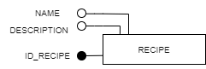

6.6 SENSOR TABLE

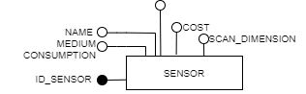
The scan dimensions corresponds to the fruit dimensions : SMALL, MEDIUM, LARGE

6.7 FRESHNESS TABLE

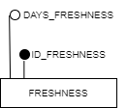

6.8 FINAL SCHEMA
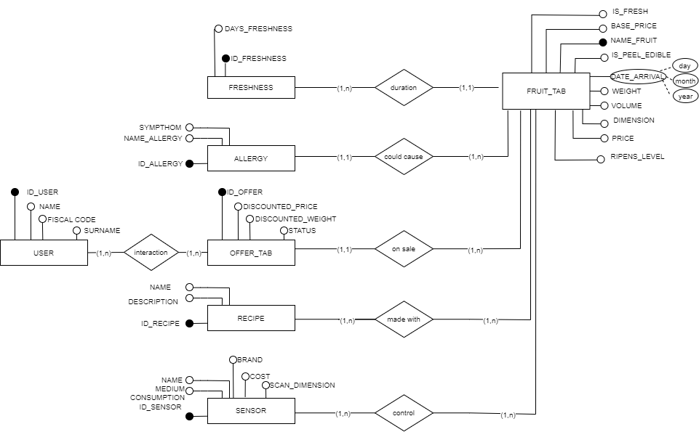

7. Add constraints
Below there are some of the constraints that cannot be represented in the ER scheme
- The fruit is rotten (not fresh) / not salabe in two cases:
  - The days of guaranteed freshness are over
  - The ripens level are 0
- Clients can only buy offer instead of Customer that can add/delete offer
- An offer deleted by an operator user is different from an offer bought by a customer
- Fruits increase their ripens level every day
- There are three types of sensor: BIG, MEDIUM, SMALL and for each size, a sensor could scan only a smaller or equal fruit dimension.
  - BIG SENSOR could scan BIG, MEDIUM, SMALL fruits
  - MEDIUM SENSOR could scan MEDIUM and SMALL fruits
  - SMALL sensor could scan only SMALL fruits
- The fact that an OFFER on a not FRESH fruit is not allowed
- The fact that the customer should see only an offer on FRESH fruits

8. Logical Design

8.1 Analysis of redundancy

It was decided to use date instead of dateTime for represent the date of arrival of a fruit in the store.
This imply that the attribute ‘hours of arrival’ is unnecessary. For this reason this attribute is deleted.

8.2 Removal of composite and multivalued attribute

The only multivalued attribute is the date format. It is composed by three fields:
- Day
- Month
- Year
It was decided to maintain this multivalued attribute because oracle databases can support this data format.

8.3. Removal of hierarchies
ù
No hierarchies found.

8.4. Partitioning/Merging of concepts

No partitioning or merging.

8.5. Choice of primary keys

The primary key of all entity expect FRUIT Table are number and represent a unique code for each entity.
For fruit table the attribute ‘name’ was chosen as primary key.

8.6 New Business Rules
No new business rules.

9.0 Physical Design

9.1 Procedures
All the procedures are used in job schedulers.

FRESHNESS CHECK PROCEDURE

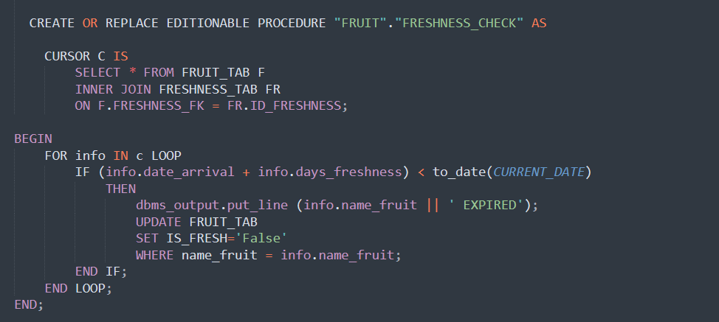
This procedure checks if a fruit is fresh or not. To do that the procedure checks if the date of arrival of the fruit in the store, added to the number of days of freshness guaranteed, is lesser than the daily date. If so, then set the attribute is_fresh of that fruit to False because it is rotten and no longer fresh.

FRESHNESS DECAY PROCEDURE

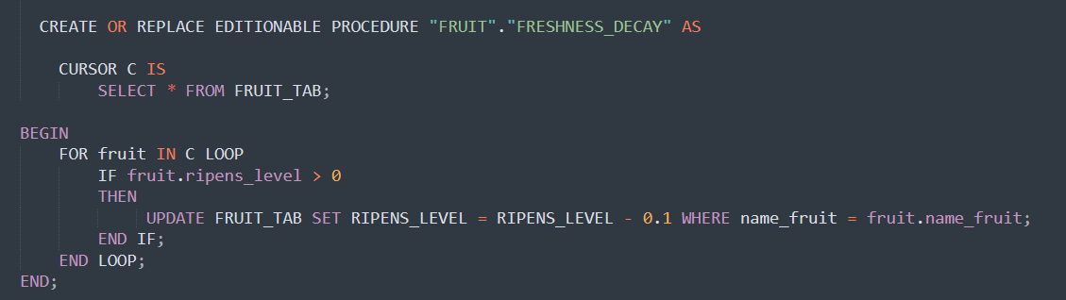
This procedure subtracts 0.1 to the ripens level of each fruit. This procedure simulate the natural fruit aging process.

CREATE OFFER ON LOW RIPENS LEVEL PROCEDURE

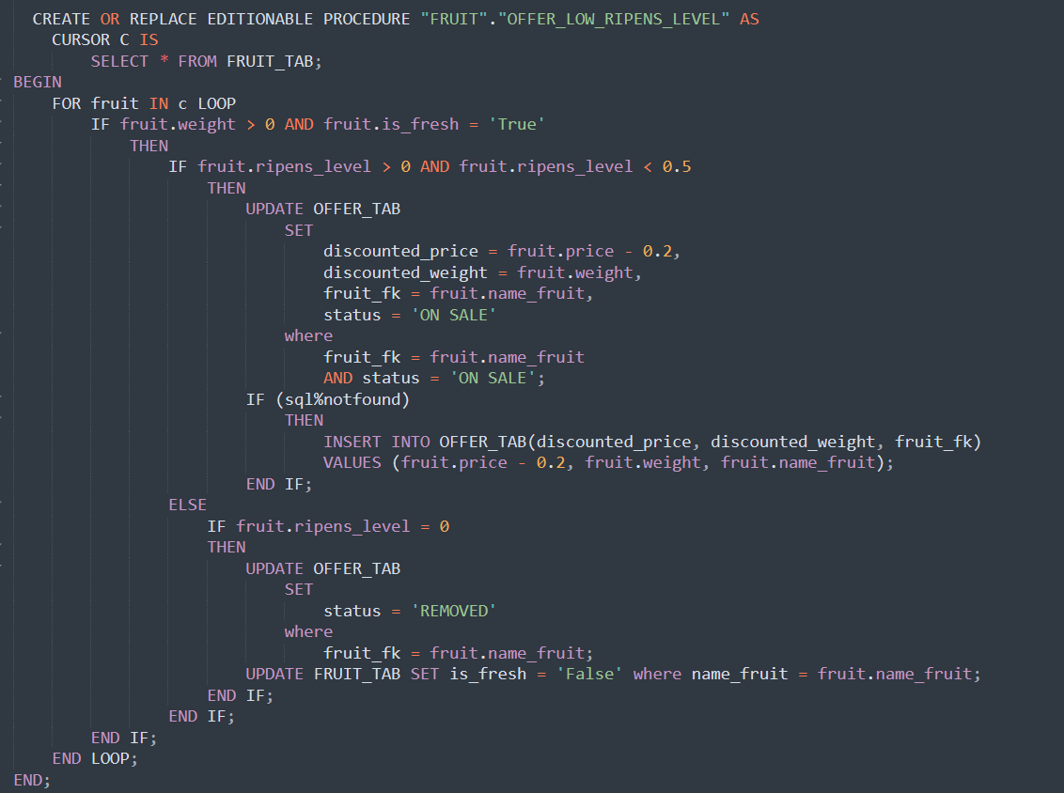
The objective of this procedure is to simulate the creation of an offer when the level of ripeness of a fresh fruit is very low (near to 0). Of course, all the fruit weight in the system is involved in the offer.
In this way the aim is to sell the entire stock of ripe fruit as soon as possible. To do that every time this procedure is execute the discounted price of the fruit is decreased by 0.20€.
When this procedure detects a potential fruit to put on offer, it tries to update an offer with the new price and, if no rows are affected from this update query, we are in the case that there is no offer for that fruit and so the next step is to create a new one.
Finally, when this procedure finds a fruit with ripens level 0, then all the offers on that fruit are set to ‘REMOVED’ and customer are no longer able to see those offers.
The threshold used to the ripens level is 0.4. Therefore a fruit is a suitable candidate for this procedure when its ripens level is 0.4 or less.

REFILL PROCEDURE

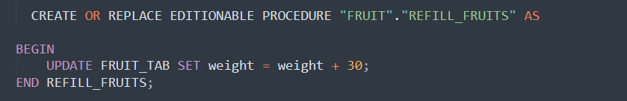
Increate fruits quantity by 30 kg.

9.2 Triggers

CALCUALTE PRICE TRIGGER

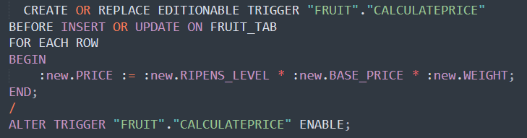

This trigger recalculates the price of the fruit based on the base price, the ripens level and the weight.
The formula is the following:
NEW_PRICE = BASE_PRICE * WEIGHT * RIPENS_LEVEL

INSERT FRUIT SENSOR TRIGGER

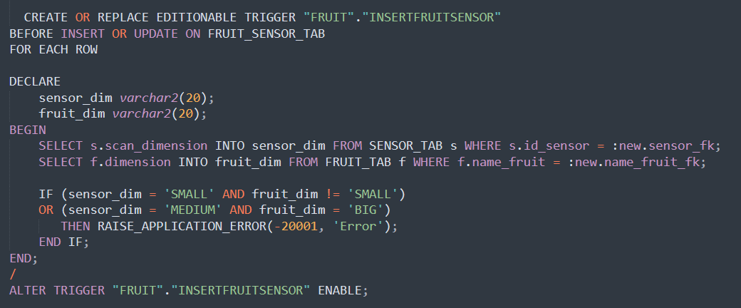

This trigger guarantee that for each size, a sensor could scan only a smaller or equal fruit dimension.
  - BIG SENSOR could scan BIG, MEDIUM, SMALL fruits
  - MEDIUM SENSOR could scan MEDIUM and SMALL fruits
  - SMALL sensor could scan only SMALL fruits

9.3 Views
Two views are created for CUSTOMER experience. In this way the customer are able to:
- view all the info on a fruit

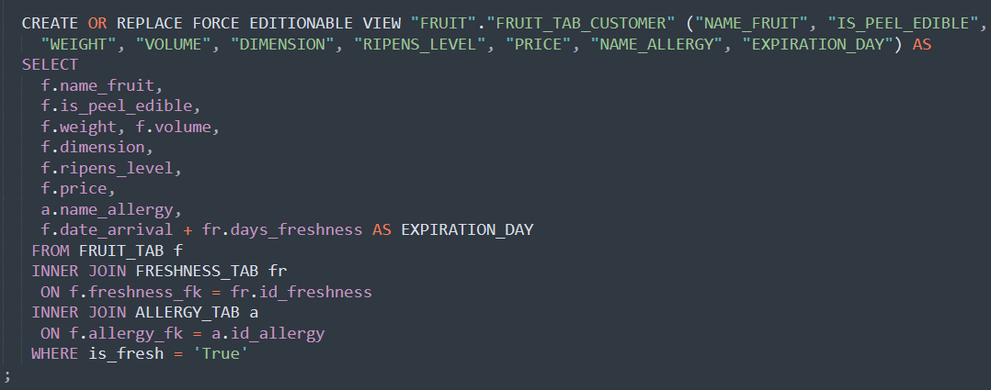

- view only ‘ON SALE’ offer which means view all available offer on fresh fruits

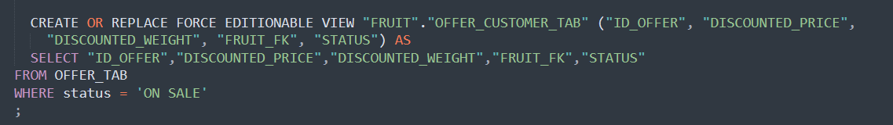

The last view is created to keep track of the customer purchases. This view shows all info about a customer and the offer that he/she has bought.
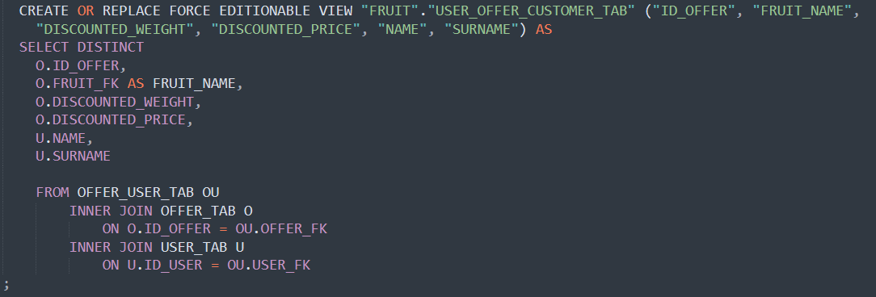

9.4 JOB SCHEDULERS

I created also 4 job schedulers, one per each procedure and in the following configuration the repeating time of the job is set to 1 minute but in a real case scenario all these jobs are designed to be run daily.

FRESHNESS CHECK JOB

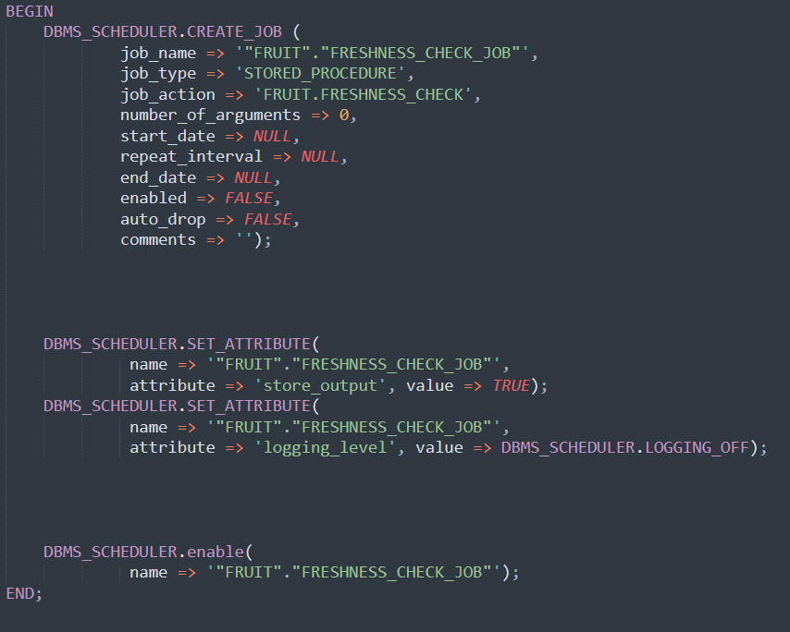

FRESHNESS DECAY JOB

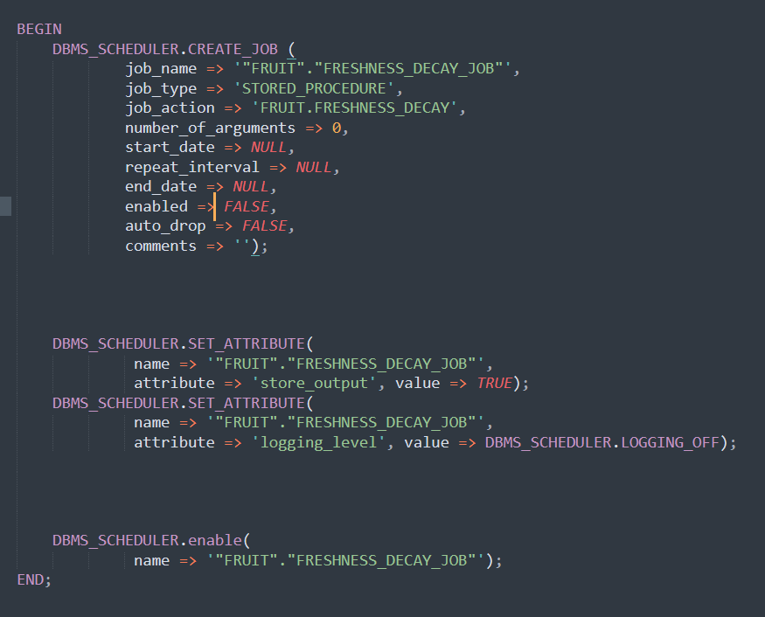

OFFER ON LOW LEVEL RIPENS JOB

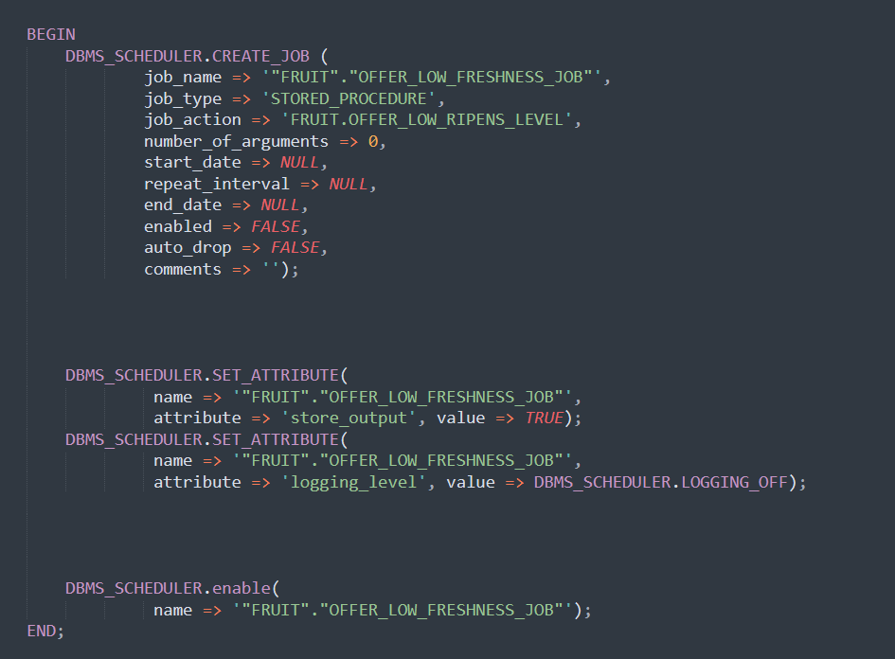

REFILL PROCEDURE

